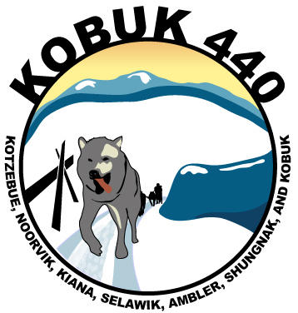
Kobuk 440 Racing Association
2016 Race Schedule

Race | Date | Start Time | Number of Dogs/ Drawing Date / other info.
Noatak 120 | January 30,31 | 10:00 AM | 12 dogs/ Jan.29, 6:00pm
Kobuk 440 | April 7-10 | 12:30 PM | 12 dogs/March 24th for $540 rate Entry Fees Due/ April 4, 12:00PM Food Drops Due at Bering Air/ April 6, pre-race mushers meeting and drawing/ April 11,post-race mushers meeting, banquet and awards ceremony
Junior Kobuk 440 | April 23,24 | 12:00 PM | 8 dogs 25 mile out, camp out at Saqaugiin Creek, 25 mile race back on Sunday.
Junior Three Dog and One Dog Races | April 24 | 2:00 PM | 3 dogs 1 mile, hotdog roast and award ceremony on the ice with Junior Kobuk 440 race finish.

